Input spreadsheet (csv) file.

Select as inputs all but the last field…. Set it as target. Ignore Date and Time factor.

In the data window set as the Target Type Categoric.

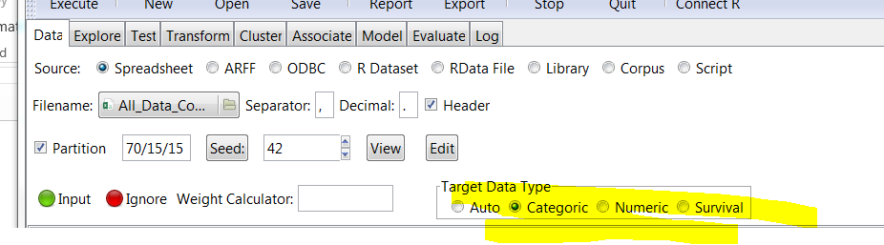

Execute data again, then go to Model.

Select Tree

